Project Design Phase

**Solution Architecture**

|  |  |
| --- | --- |
| Date | 20 July 2025 |
| Team ID | LTVIP2025TMID41443 |
| Project Name | Transfer Learning-Based Classification of Poultry Diseases for Enhanced Health Management |
| Maximum Marks | 4 Marks |

Solution Architecture:

1. User Interface (Mobile/Web App)

* Built using Android Studio (for mobile) or Streamlit/Flask (for web).
* Allows farmers to upload or capture chicken images.
* Displays predicted disease and treatment suggestions.
* Supports offline mode for rural users with limited internet access.

2. AI Model – Transfer Learning (Backend)

* Pretrained CNN models like ResNet50, InceptionV3, or VGG16 are used.
* Fine-tuned with a dataset containing poultry images across four categories:  
  Coccidiosis, Salmonella, Newcastle Disease, and Healthy.
* Deployed as a backend service to receive images and return predictions in real-time.

3. Dataset & Image Preprocessing

* Image folders organized by disease categories.
* Images are resized, normalized, and augmented for training.
* Dataset split into train, validation, and test folders.

**Example - Solution Architecture Diagram:**

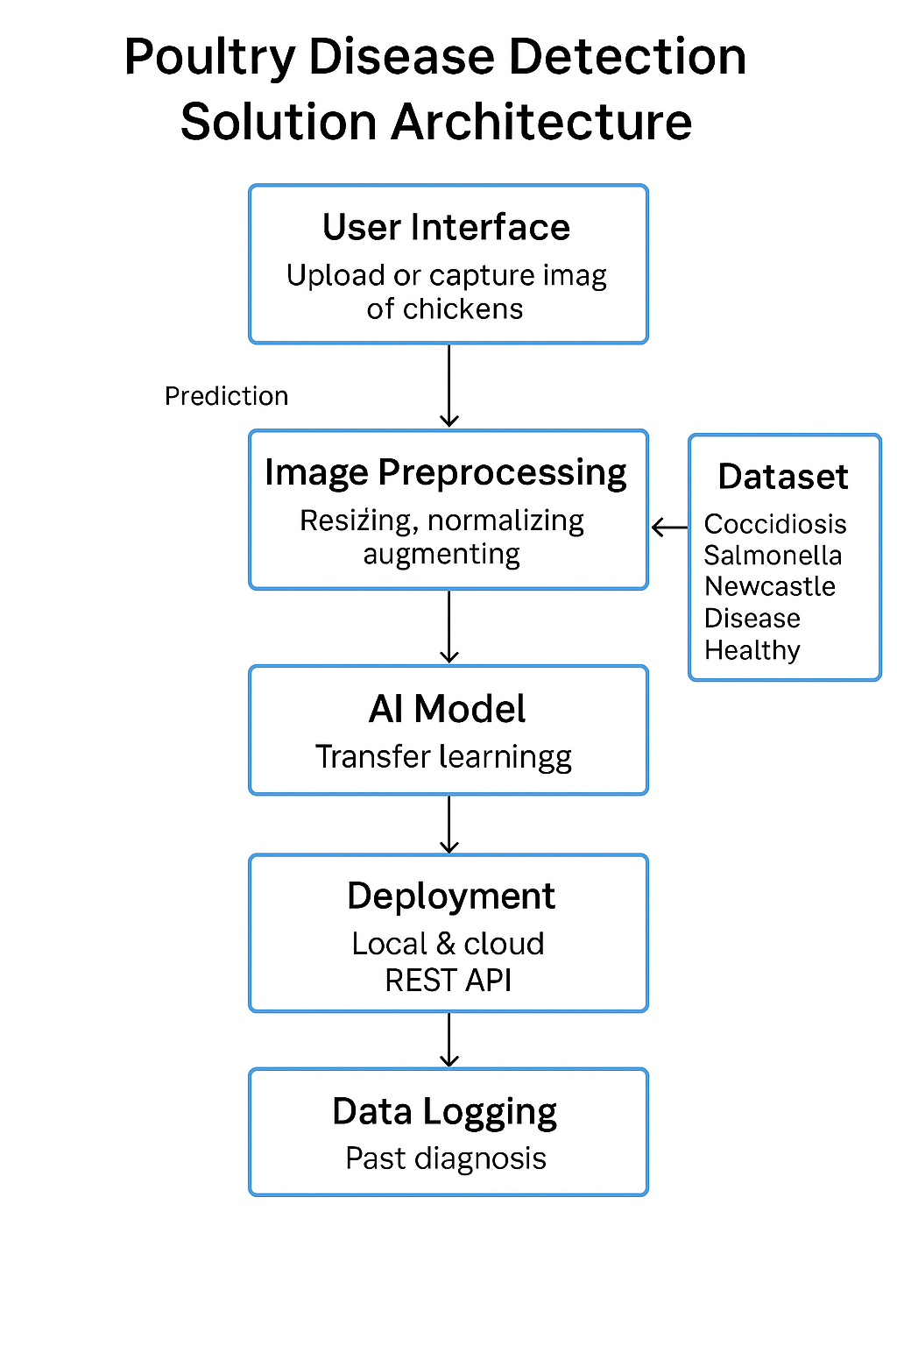

Figure 1: Architecture and data flow of Transfer Learning-Based Classification of Poultry Diseases for Enhanced Health Management